Technologies
- Jenkins
- Docker
- AWS
Jenkins: It is a build tool used to automate the build process in the production, so that the project will be built in the production machine
Pre-requisites
- You need to have a project
- Push the project to the GIT
- Install Jenkins with Java 21, Git & Maven plugins
- Configure Jenkins to build the jar file
In Jenkins you get a war file that you can launch to use the Jenkins application, these days java command can be used to run the war file using java -jar file.name.war
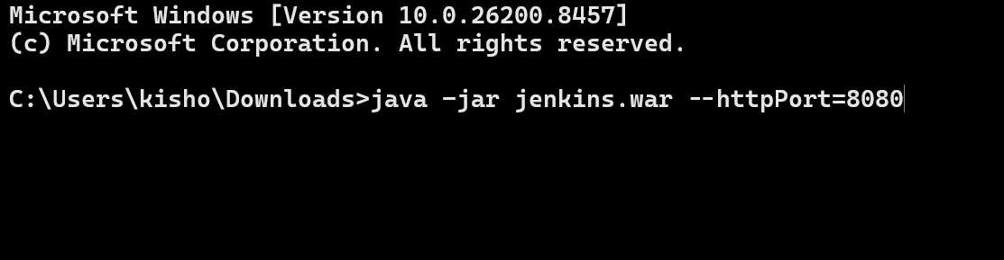
After installation you will see admin password
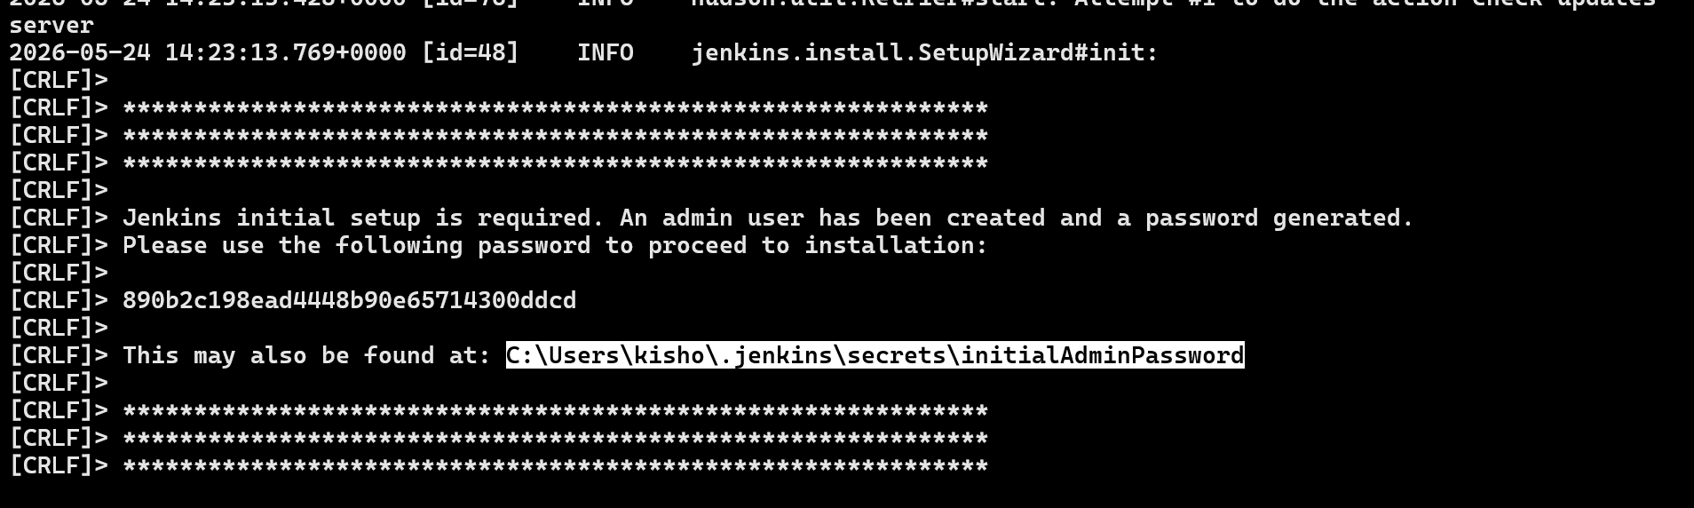
Now visit http://localhost:8080 you will see
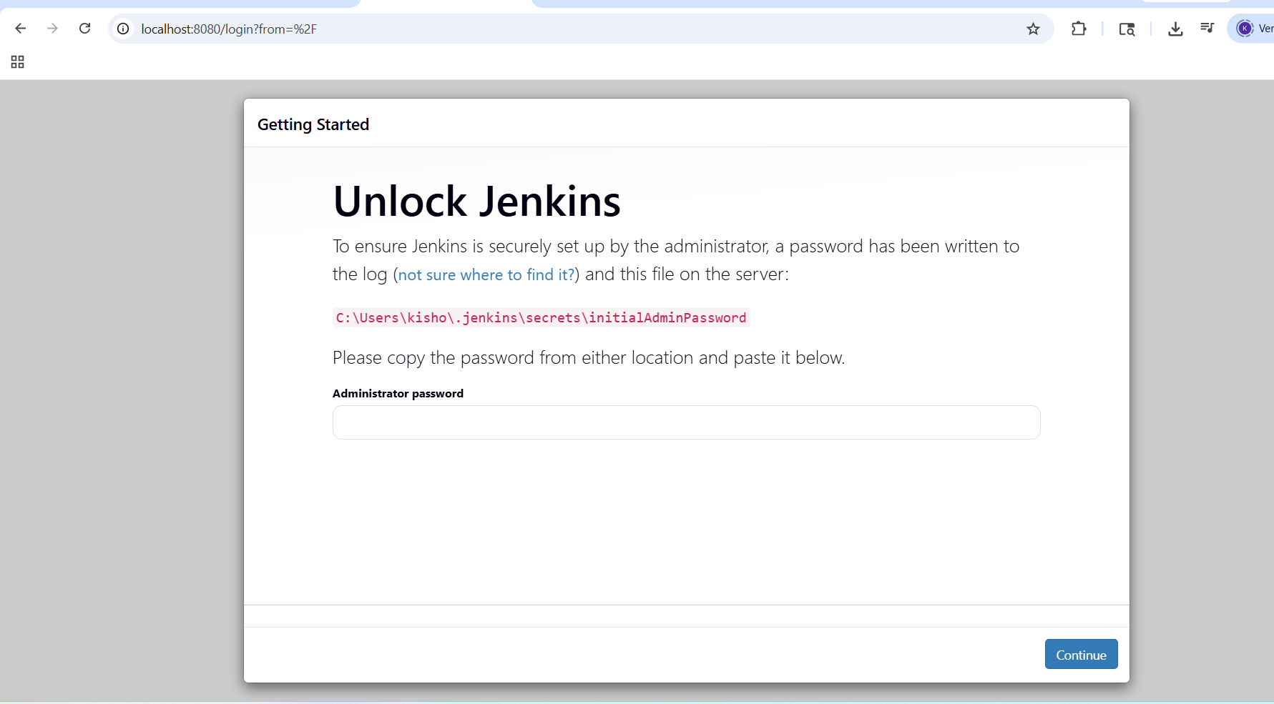
Configure JDK by visiting tools in the configuration
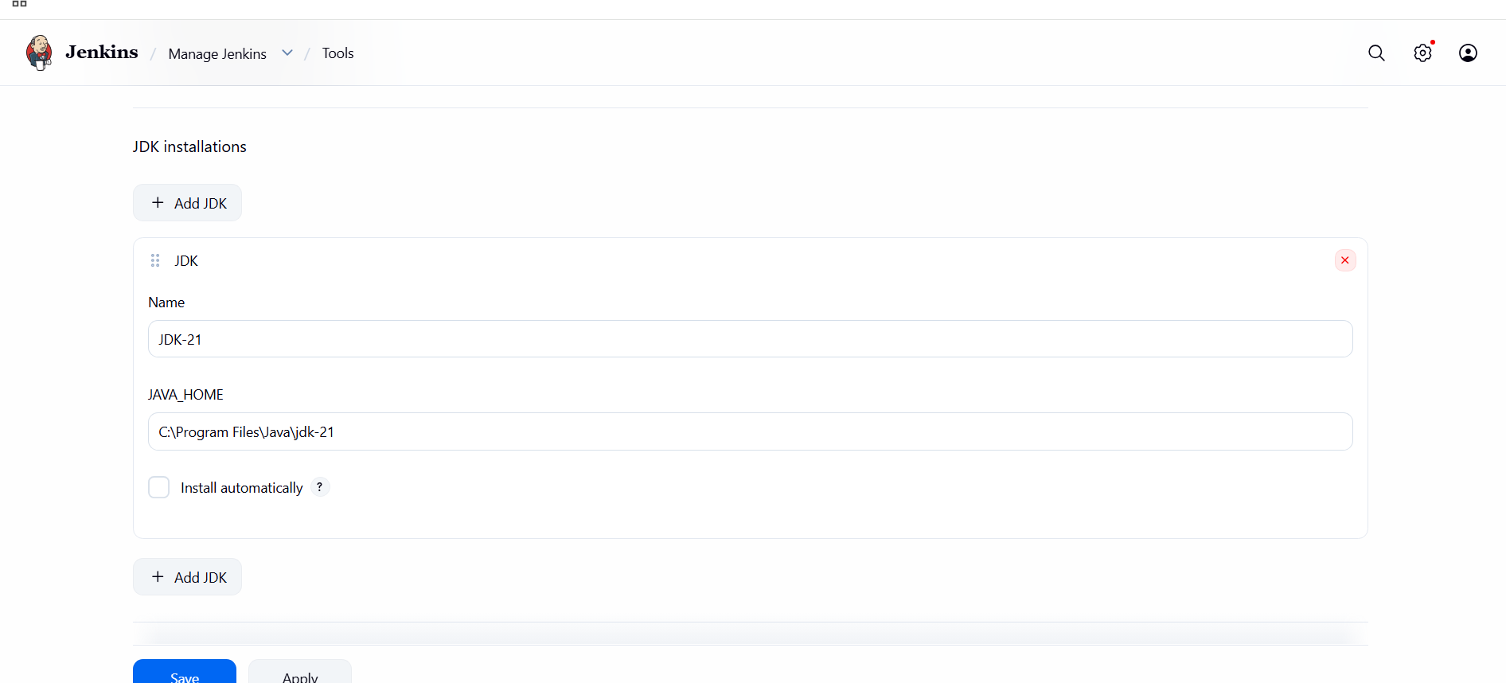
Next you need to configure GIT
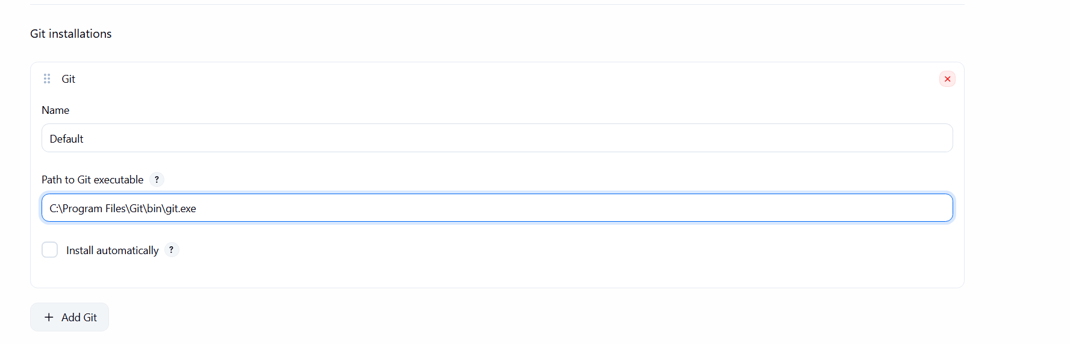
You need configure Maven
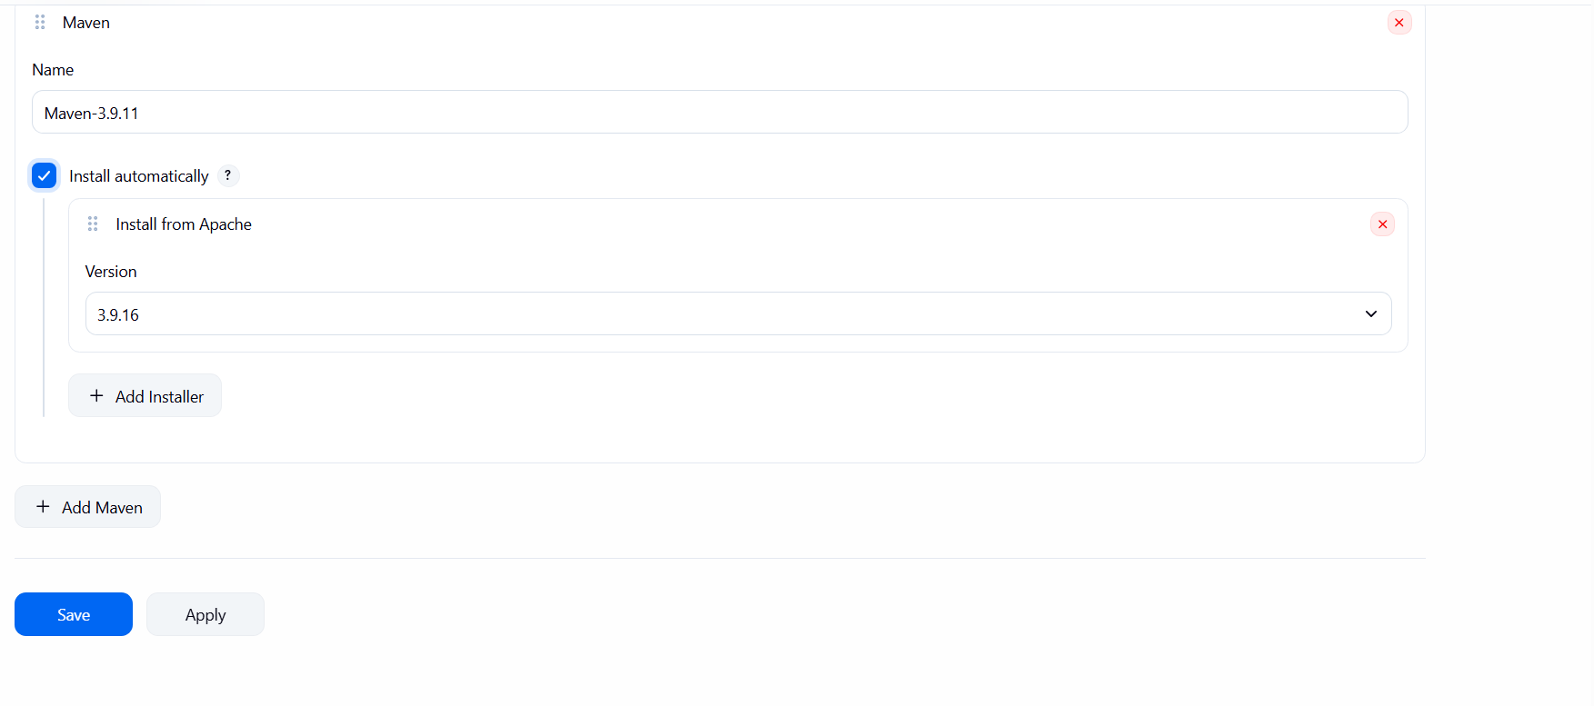

AWS - It provides infrastructure, so that we can use on a rent or lease basis, it will be charged as per the usage
EC2: Elastic Cloud Computing - this provides difference machines for us some are free and some are charged

